My first impressions of the city of Amsterdam was that it was very oxymoronic. Chaotic yet orderly, having to wear the coat one day and being out in shorts the next, and stunning architecture on every street and yet graffiti and stickers on every corner. It is also one of the few places that welcomes you and makes you feel so one with the city that you could walk into the metro and you couldn't tell who was Dutch. Overtime I have come to truly appreciate this contrast and unknowingly have adopted it into my life. The city teaches you what it truly means to have a balanced life - that you can pull 12-hour library days on a Thursday and also be out with your friends in Rembrandtplein till 4am on a Saturday. It teaches you that you may have the busiest of days but one should always take out time to slow down and enjoy few moments in the sun with a friend. It's perplexing how most people don't see Amsterdam beyond it's red light district and the types of cafes that exist there, when it's a city that shows you that life can be so much more - if you only look up and see.

I have attached screenshots of the playlist on the following page.
Here is the link https://open.spotify.com/playlist/5kJBJHR2rvM8KTjpEKvAAa?si=e796bcf4240141fe

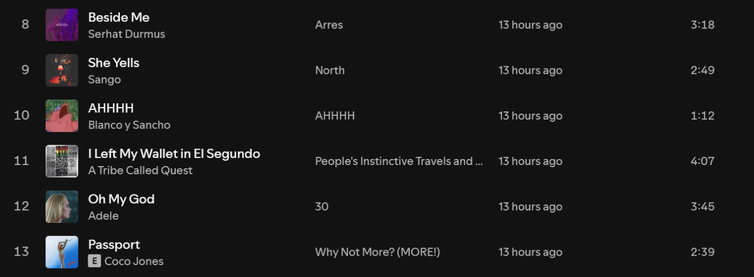
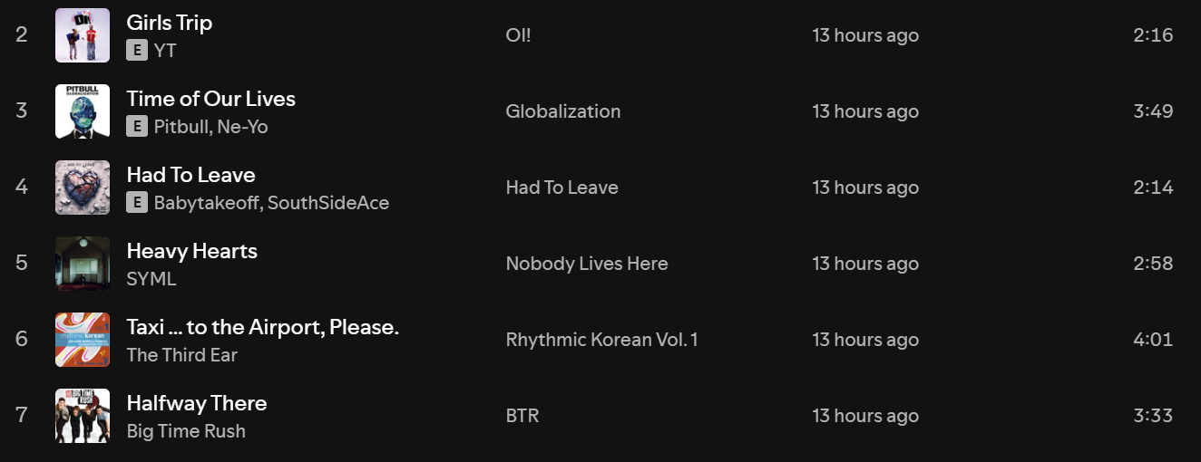
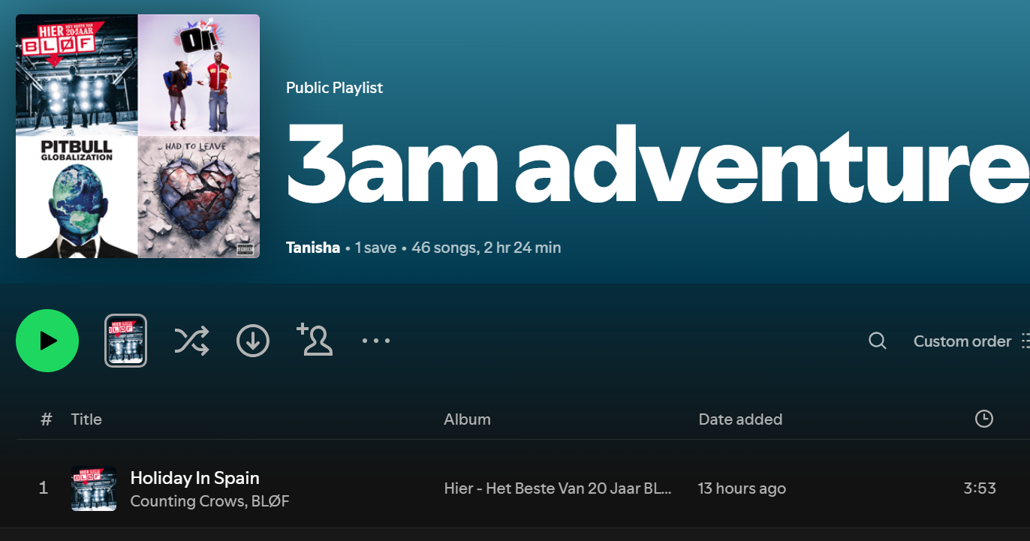

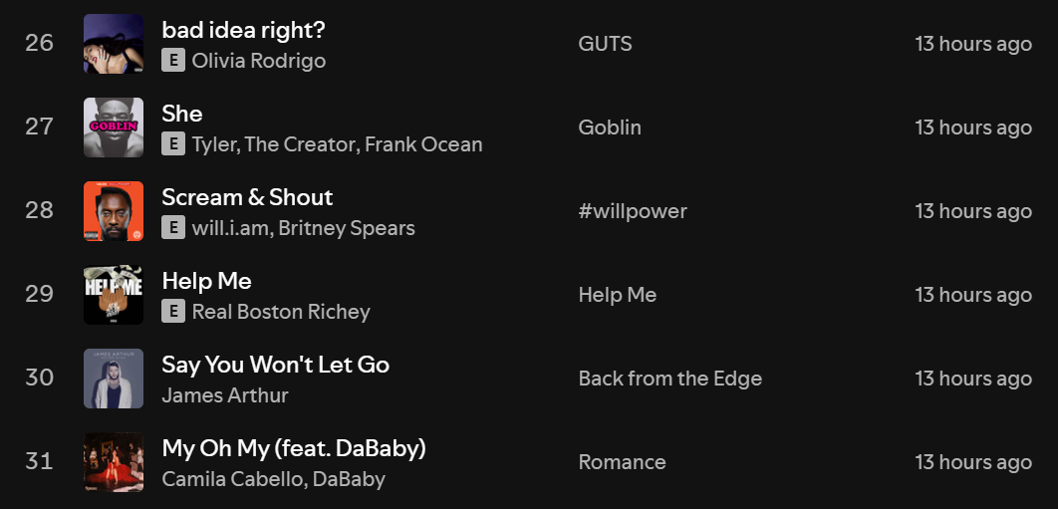
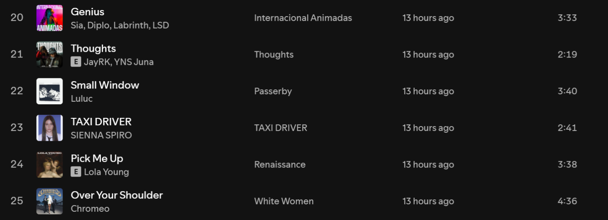
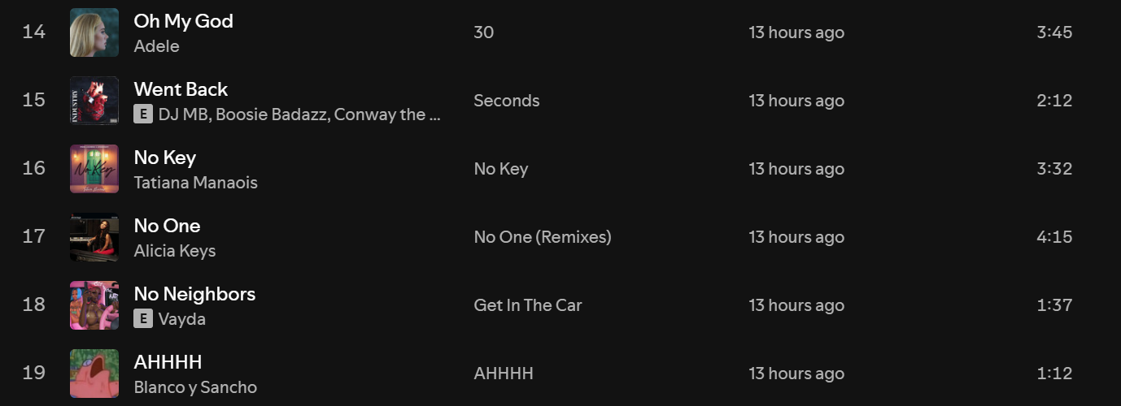
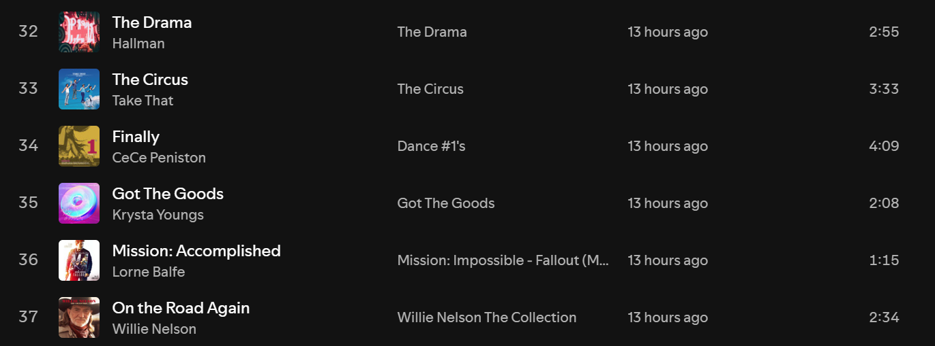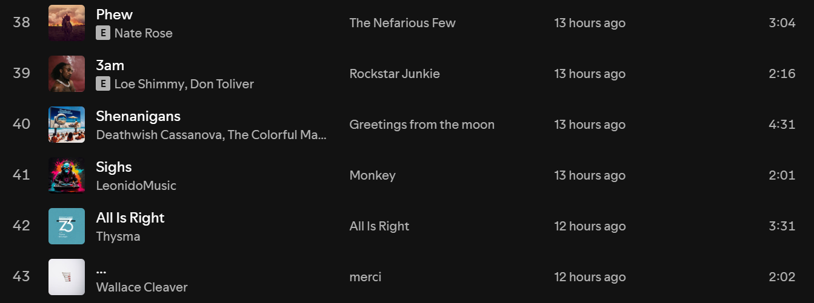
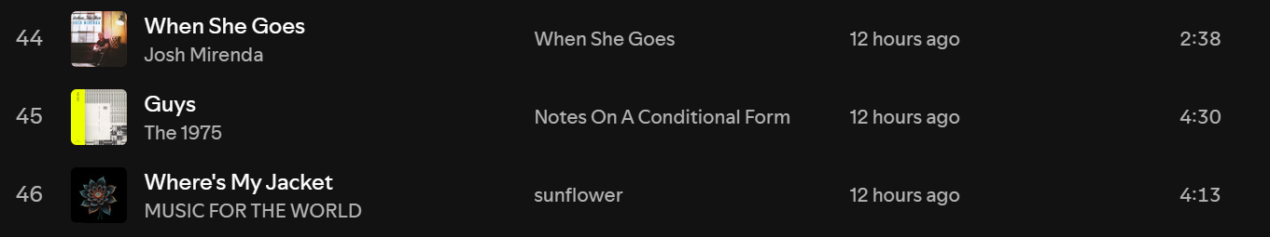

For this I am thinking about a specific route that I’ve taken multiple times from the Waterlooplein metro station to the Singel library at Koningsplein. As I leave the station and take a right over the bridge to walk along the canal, I always hear the sound of the bikes going over the tram rails. Often, one also hears titbits of people’s everyday lives as they sit on the bench catching up with their friends. The sounds of the next five minutes of the walk depends on the weather. On sunny days, it is often the confused tourists trying to find their way. On gloomy days I can feel the light drizzle that is almost always there along with the sounds of my umbrella holding on to its dear life against the angry wind, and one too many times I have heard the inevitable crack of its ribs. For the past year, about seven minutes in, I have always felt the unevenness of the pavement due the seemingly never-ending construction which causes me to cross the street. As you approach the square, if you get lucky you get to hear the bells of the clock tower along with the bustling sounds of the customers in this sweet smelling stroopwaffle shop next to Muizenhuis. The last stretch of my walk to the library is often filled with the thunks of the bike baskets as they go over the humps and this thirteen minute walk always ends with the sound of the turnstile as I enter Singel.

One of the most emotionally connecting and grounding experiences I have ever had was last spring in Dubrovnik. It had been a long day of exploring and we were back at the Airbnb. I had just freshened up, washed all the sand from my hair and in that instant felt the urge to drag a chair and sit on the porch under the night sky. So, finally around 11:30 in the night after squaring up everything, I picked up my sweatshirt and my phone bundled up in my earphones and went outside. It was the first moment of solitude I had had all day, and the pleasant breeze against my damp hair along with the smell of sand and the sea felt good. It was a beautiful night with a sky filled with more stars than I had ever seen at once. I just sat there observing them, feeling a sense of gratitude that I could experience this at 19 in a city my parents had never been, when suddenly my eyes lit up. Using an app on my phone I confirmed that I did indeed spot a constellation, by myself, out in the nature. It was an Ursa Major. Feeling a sense of wonder and pride, I started humming a song "...it was all yellow..." seemingly out of nowhere. Without thinking much, I played it on Spotify and the song played - "Look at the stars. Look how they shine for you, and everything you do.". It may seem like nothing, but the sheer coincidence, the atmosphere and the lyrics immediately brought tears in my eyes. A lot of memories of the past months flashed by as I sat there all huddled up feeling emotional with a mix of joy, gratefulness and contentment. It was a simple moment, but one I truly felt anchored in.

All my life I have absolutely loved travelling. Especially internationally. Given how vast my country is and how many places there are to see just within it, it meant that international trips were not that often, maybe every three years or so. That love for travelling simultaneously also led to the love of being in airports. Just something about them - the posh feeling of being there, the boarding passes and the flight itself always got me very excited. It is also why I got extra eager when we travelled domestically by air. I have always experienced a sense of child-like wonder while travelling and have often felt a specific feeling which I could best describe as "a familiar feeling in an unfamiliar setting". It has a sense of coziness and happiness and wonder to it which in a way the word "gezellig" would describe. As I grew up and moved continents and now live on my own, the love for travelling has remained but slightly changed. After having been to a few places with my friends, I've come to realise that on each trip I have these specific moments of true wonder, instants of peace in nature or bustling cities, and my favourite - moments of reflection and introspection which have been absolutely delightful. I love travelling because it also inherently teaches me a lot - how to plan, how to work around when things go wrong, how to push myself to try new things and how to sometimes let go and just truly enjoy myself but I think the most beautiful way to describe the ‘why’ is something that I came across in "How to Explore like a Real Victorian Adventurer" which to paraphrase said that I travel to discover the extent of my own ignorance. I have always known there's something to travelling that I truly love, but the past three weeks have in a way helped me to phrase my 'why'. I've come to truly enjoy finding pieces of myself that I didn't know existed, in cities I have never been. The best way I could explain that is that feeling of a city reflecting a version of you that you didn't know, but realise is true.

As for travel writing, I would say my view has definitely changed. As a child I used to maintain travel journals where I would document things we did on trips - where we stayed, what we ate, what I wore etc. It was all very at face value, but again I didn't expect it to be anything more from a 10 year old me. Based on things we've been discussing I have come to realise that travel writing is to do less with the itinerary but more about the experiences of following that itinerary. Things I saw, felt, smelt, touched, tasted and remembered. Maybe I don't have to document every single dish I ate at every meal but I should definitely talk about the flavours I enjoyed and what they made me feel. I have also come to realise that perspective plays such a big role in travel writing because the subtext of experiences and the depth to which one interprets would be so different even between 2 friends going to the same place and experiencing the exact same things together. In my opinion, I have definitely realised the lens in which I should write things down, as I always seem to experience a lot but they seldom get translated when it comes to jotting them down.

The last few exercises of reflecting and writing about experiences haven't given me a completely different view but they have definitely been enhanced. I've known that some moments always meant a lot to me and made a great difference but it was only while reflecting and being forced to think about the experience from a sensory aspect as well, that it made me realize that there were so many elements to that memory that I did experience but didn't actively register at that point of time. It has also allowed me to think deeper about the memory in a way that I am able to formulate my feelings at that point in time in words that describe it better. Even within this reflection - the way I described why traveling appeals so much to me, I haven't ever been able to explain it better. Maybe a few weeks down the line I might be able to better that as well. Reading about my introspections now gives me a greater sense of joy as it seems to be much easier to go back in time and relive them.

On our Croatian summer trip, on day 5 in Split, my friend and I had booked a walking tour of the Diocletian's Palace where I met the most memorable person of the entire trip - our tour guide, Ivan.
I absolutely love the concept of walking tours, but it takes a truly passionate guide to make it a success. Ivan was one of them. Right from the beginning, the way he introduced himself, his jolly nature along with his natural talent of story-telling, he truly brought history to life. The most interesting part of a tour is always the personal anecdotes intertwined with the history that bring it all together. I still remember how fascinated I was with the way he began the tour - the reason why his name was Ivan. Apparently, in his class back in school there were so many Ivans that the teachers had to find other names to call them. The reason behind it was that every Croatian family back then named their firstborn sons and daughters Ivan and Ivana because the way someone pronounced the name, gave a clue if they were Croatian or not. This was one of their secret ways of identifying their enemies during wartime!
Another amusing story that he shared from his childhood that stuck with me was the feud of HBO vs the Grandmoms. It was so entertaining to walk down a street next to the palace and hear about how when HBO was shooting Game of Thrones on this street, all families were asked to close their windows. However, there was one grandma that refused to do so and kept opening it during shoots. As a result, HBO tried to negotiate with her which ended with a handsome payout for a few hours of undisturbed shooting. One can guess what happened next – pretty soon every grandma started opening the windows and HBO had a wild time with all the payouts, contracts and negotiating with the tough Croatian grandmoms!
One of the reasons I still remember Ivan was because I left the tour feeling more in love and awe of the country. Throughout the tour I had these moments of “oh my god that’s so cool”, “oh my this is so beautiful” and those pinch-me moments along with his entertaining commentary really got me to appreciate Split even more. The tour by itself was great but I think Ivan made the whole hour so much more fulfilling that even today, if anyone asks my favourite country to visit, it’s Croatia.

Writing Exercise #2
Think back to your excursion two weeks ago. You observed and documented many things while on the excursion. What was the most surprising or alarming thing you observed? Try to describe with as much detail as you can.

My entire time in Den Haag, I seemed to be weirdly focused on the trams of the city and how different they seemed to be from the ones in Amsterdam. The thing that surprised me the most, and one I noticed almost immediately, was the absence of an operator in the tram. My first thought was, “Do they not worry that tourists or even locals may just not end up paying?” This inherent sense of trust the city had in its people didn’t make sense to me because in my mind I thought, “You are asking for a loss.” Granted that back in Amsterdam there isn’t an operator always, and one could theoretically get by without paying there. However, at least during tourist seasons, during the day on the most popular routes there is almost always an operator vigilantly checking to see if the people are tapping in or not. In the 25 minute tram ride to the beach, I kept thinking about it and a thought occurred to me that not everyone would notice this and have the exact same line of thinking. My immediate instinct was to believe that people are inherently dishonest and if given a chance, they will break the rules. Seems kind of pessimistic. But I think this also has to do with where one is from. Back home, at least based on the perspective I’ve developed in the past 20 years, I know that if there was no one to monitor the abidance of rules, the public would break every single one of them to serve their own interests and the group of people who still would because ‘it is the right thing to do’ would be the minority. But to be fair, that is human nature, and I have also observed this a lot in Amsterdam as well, especially at my metro stop. Then again, at metros it is monitored and yet people jump the turnstiles. One can only wonder how disproportionate the ov taps would be to the number of people on the tram and I did wonder about this – the entire 25 minutes.

Writing Exercise #4
Look back at a favourite picture from the ‘pitched’ trip which shows the landscape of the lace in detail, regardless of whether it is an urban or rural setting. Describe the picture in as much detail as you can. Can you try to recreate the picture with words? How can you describe the picture so that an individual could see it without actually seeing it? Try to describe between 300-400 words. Again, make sure this writing exercise does not overlap with a previous writing exercise.

Looking at my gallery at the moment, I am seeing a picture I took on my phone on 27th April 2024 at 11:20am in Plitvicka Jezera National Park in Croatia. There’s a lake in the middle and hills on either side underneath the blue sky. Starting from the top, the sky was the perfect shade of blue that comes to mind when one hears the phrase ‘sky blue’. It’s not a clear sky though – there are clouds – gigantic, white fluffy clouds with shades of light grey in certain places. Like it might drizzle any moment but it also might get sunny the next. The blue of the lake, surprisingly, did not reflect the same shade. Instead, it seems to be taking on a different hue every few metres or so. Pristine, clear waters that seem to be gently making their way south in shades of emerald green, emerald blue, forest green in some areas and the remaining spots are in the shades of cerulean blue. Waters that you know without touching would feel absolutely fresh, crisp almost. The hills on either side are layered with trees. There are places where you see the flat surface of the hillock but mostly, they seemed to be covered with dense shrubbery and canopy. The greens of the hills take on different shades depending on the way the sunlight hits them. All the way from lime green to forest green. Right in the midst of all this nature, in the centre of the lake there is a duck. Just swimming peacefully amidst the tranquillity. One can almost feel the serenity themselves as though it is not the duck, but themselves that seems to be swimming there. The picture truly seems to be an HD wallpaper come to life.

Three possible ways I can start the essay :
- If the whole trip had to be summarized with 2 songs, my choices would be Ain’t Your Mama by Jennifer Lopez and Yellow by Coldplay. Not that I had to pick up after a guy (it was a girls trip) or that any of the views and landscapes were significantly yellow (it was all shades of greens, blues and the iconic orange of Croatian roofs) but because these two songs, in their tunes, have captured the best days of the trip.
- Standing at the bus station, panting, I realised I needed to get to the national park that was 150km away but the next bus was too late and any taxis I could find were 120 euros or more.

Visual Photos, Music (plays a big role), Recordings, Scrap booking stuff – tickets, bands, postcards, memories, my trip itinerary

The custom of coperto really seemed unexpected on our visit to Venice. I’m sure everyone who has gone to Italy experiences the exact same thing. I still to do day do not understand why we get charged for the plates and cutlery when we are paying for food. In my mind it seems to be another way to ask to pay for service but they deny that it isn’t tips. But I guess if you want to have good Italian food one must have to suffer through having to pay 4 euros extra every meal.

